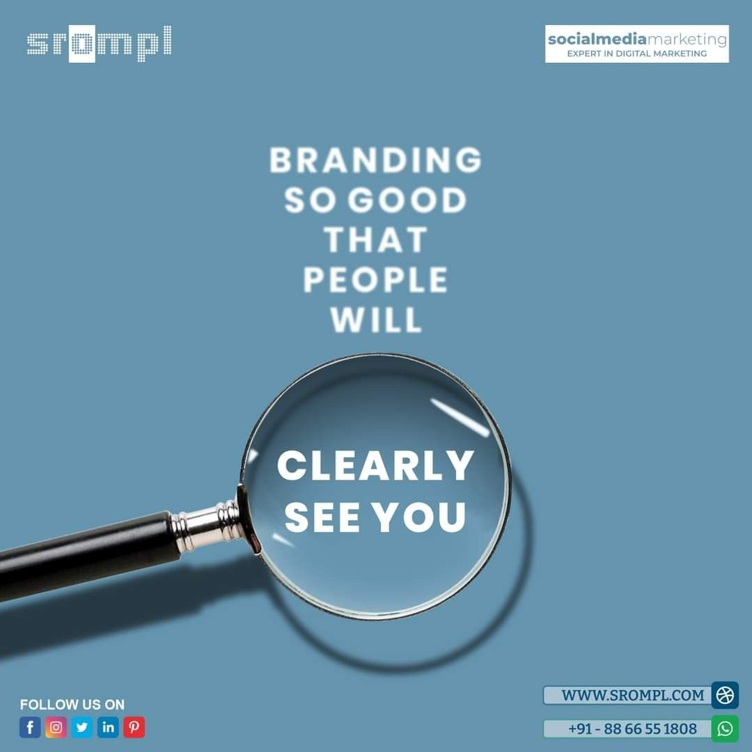

We understand businesses/individuals (change in 2 sec)

That’s why we are one of the best PR agencies across the globe.

Shaping Stories, Building Brands – Your Trusted PR Partner **(BRANDLOGG FACEUP)**

**BRANDLOGG FACEUP** is a dynamic PR program that enhances individuals and business’s public relations, thus amplifying their reputation in media.

**BRANDLOGG FACEUP** is a strategic program that specializes in managing and enhancing the reputation, communication, and relationships of businesses, individuals, and organizations.

**BRANDLOGG FACEUP** is a top PR program around the globe that boosts brand/ individual reputation and provides positive public image.

**BRANDLOGG FACEUP** is an elite PR program that specializes in reputation management through proactive monitoring and mitigates any negative publicity that harms your brand image.

Elevate your public presence and shape your reputation with BRANDLOGG FACEUP

Best PR agency around the globe

Get ready to see an increase in your brand’s visibility and enhanced Public relations with our top notch PR experts.

Looking to establish a strong brand presence in the severely competitive market of India? Your search ends here!!!

With a passion for storytelling and a capacity for strategic communication, we craft compelling campaigns that resonate across diverse platforms. Our team of experienced professionals brings a wealth of industry knowledge, fostering relationships with media and influencers.

Request a call back

Why choose Brandlogg FACEUP?



When you think of public image management, finding the best public relations program comes before as the most demanding task. But look no further because **BRANDLOGG FACEUP** is just perfect for a transformative and unparalleled approach to enhancing your public reputation and visibility.

With a dedicated team of experienced PR professionals, we offer a unique blend of strategic thinking and creative execution that sets us apart.

Our track record of delivering exceptional results across diverse industries speaks to our commitment to your success. We don't just manage campaigns; we craft compelling narratives that resonate with your target audience, creating lasting impressions.

From media relations to crisis management, our comprehensive services are tailored to meet your specific needs and goals. With a focus on transparent communication, innovation, and a deep understanding of market dynamics, we're the partner you can rely on to elevate your brand to new heights in today's competitive era.

Our services

1. Social media surveillance – We use specialized tools that help you keep an eye on every detail on any given platform that is being navigated in the media about you.
2. Digital and social media- Our team of professionals helps in maintaining your digital presence by crafting powerful campaigns that enhance your digital visibility.
3. Competitor analysis- Not just you but we keep a check on your competitors as well. This gives you an insight into the recent trends in the market.
4. Public relations - Our exceptional PR team translates client expectations into forward-thinking outcomes that drive essential communication strategies and contribute significant value to their business objectives.
5. Online reputation management - Navigating digital space, we safeguard your brand's online image, curating positive perceptions and refreshing trust through meticulous reputation management.
6. Media relations – Either it’s an established place or a new venture, media coordination and relations are very important. From reaching out to industry professionals to managing on different platforms, our team does it all.

Our portfolio

(Images of places we have placed our articles on)



Our testimonials

(Previous clients and their reviews)

Connect with us

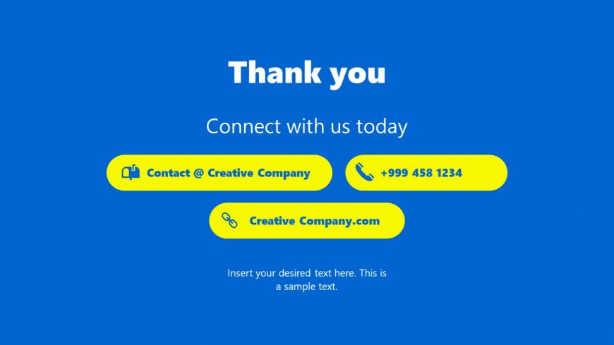

.

We hope you don’t feel left out when I say that more than **8.5 million MSMEs are currently active on Google and all of them are highly profitable.**

**Still feeling that putting ads on Google or introducing your new products through internet is a hassle.**

**Worry not!!**

**@**

https://brandlogg.com/blog/services/marketing/best-way-to-use-linkedin-for-b2b-marketing/